# **Investigating the impact of SAFE Act passage on incidence of gun violence in New York City**

Rachel C. Weber, MPH Candidate

# **Background**

New York City has a tumultuous history of gun violence. After a significant drop in gun violence in the 1990’s, New York City has made steady progress in reducing shooting incidences in the new millennium3. The New York Times reported in August 2019 that gun violence is at a two-decade low for the city4. Many researchers cite the state’s strong gun control laws and progressive police training as reasons for New York’s improvement.6 Along with state-level regulation, the national culture around gun ownership and resulting violence has been in major flux. Though New York City’s worst years of gun violence are in the past, growing national incidence of mass shootings has brought community activists to action.

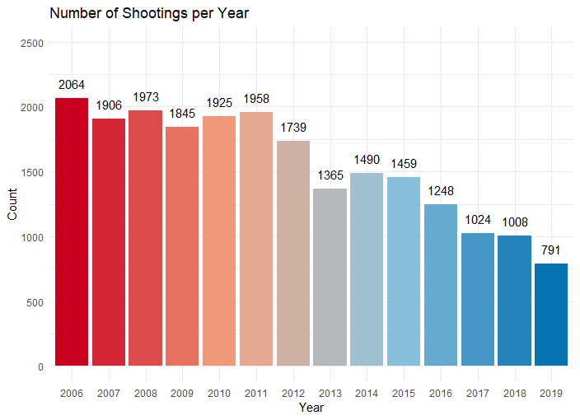

*Figure 1: Histogram of Number of Shootings in NYC per year (2006-****September*** *2019)*

Following the Sandy Hook shooting in December 2012 and the December 24th Webster shooting, New York passed the Secure Ammunition and Firearms Enforcement Act (SAFE Act), which contains several firearms regulations. These include broader definitions of ‘assault style weapons’, prohibitions on high capacity magazines, mandated background checks, and safe storage provisions. In 2010, New York City implemented Chicago’s Cure Violence public health model to use community outreach as a means of curbing gun violence. As of 2017 there were 18 active Cure Violence programs around the city working to ‘denormalize’ gun violence1.

In this analysis we built an interrupted time series negative binomial model to ascertain the number of shootings expected on a given day. We used incidence rate ratios to understand the impact the SAFE act had on gun violence and assess how this may have impacted the likelihood of a shooting-free weekend, like that which occurred in October 2018. Such was heralded as a success of legislation and improved policing, but the question remains of how much its likelihood increased following SAFE Act passage.

**Data**

Data are supplied by NYC Open Data. The dataset spans years 2006 through September 2019 and includes 5021 consecutive days. Each row contains the time and date of a shooting, the location (precinct and latitude/longitude), and perpetrator/victim demographic information.

Data is manually extracted every quarter and reviewed by the Office of Management Analysis and Planning. Data is intended for public use, to “explore the nature of shooting/criminal activity” in NYC. Data for the final quarter in 2019 are missing as the most recent review period was stalled—likely as a result of COVID-19.

Number of shootings per day ranged from 0 to 30 with an average of 4.3 shootings per day and median of 3. There were 387 days without shootings in the dataset. This represents 8% of the 5021 days.

**Methods**

All analyses were performed in R version 3.6.0. Only date and time data were used for analysis as adjustment for precinct/location and victim/perpetrator characteristics were beyond the scope of this study. Date and time fields have zero missing values. Days without shootings were not present in the dataset. These days were added as new rows with 0 shootings to allow for counts and visualizations of such. Variables for month and year were added using the date variable. It has been documented that shooting incidence changes depending on time of year, rising in the summer and falling in the winter2,5. The extent to which this data agrees with this understanding can be seen in the shooting incidence graph below.

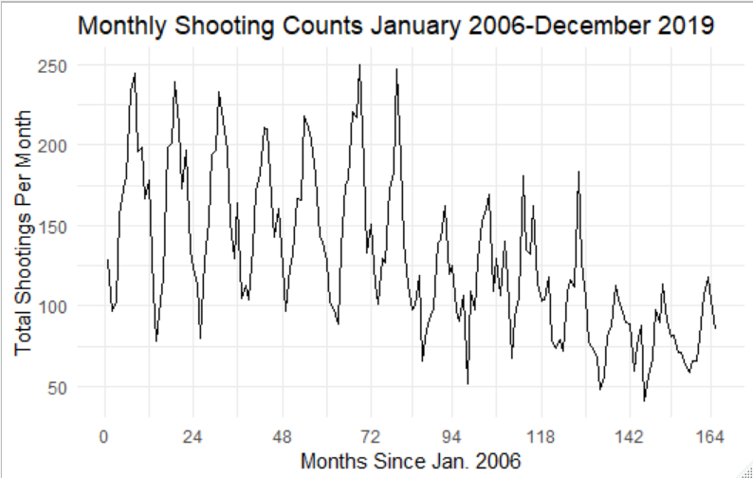

*Figure 2: Shooting incidence per month 2006-****September*** *2019*

Month was included as a factor variable to accommodate these time of year fluctuations and to give higher resolution to such changes than a four-level seasonal variable could provide. Number of shootings also varies with day of the week, with more shootings during weekends, so day of week was included as a factor variable. Finally, an interrupted time series variable for pre/post SAFE act implementation was included to understand the effect this new legislation may have had on incidence of gun violence at the daily and monthly level. Models allowed for a level shift and a change in slope at the time of SAFE Act implementation, 01/13/2013. A Generalized Linear Model with Negative Binomial distribution and log link, i.e. Negative Binomial regression, was used to model the outcome, number of shootings per day. Negative Binomial is a generalization of Poisson that allows overdispersion, i.e. variance greater than the mean. Rate ratios shown in Figure 2 are exponentiated regression coefficients from this model.

Univariate modeling was conducted to identify variables associated with changes in shooting incidence. All variables were found to be statistically significant (p < .05) in univariate analysis and so were used in multivariable modeling. Models were built at the day level and interpreted at the month level to better visualize variation in incidence rate ratios.

# **Findings**

The model estimating shootings-per-day suggested that month of year, day of the week, and SAFE Act passage were significantly associated with our expected shooting rates (Figure 2Days Tuesday, Wednesday and Thursday are estimated to decrease our expectation of shooting incidence by 14-19% relative to Fridays. Compared with Fridays, Saturday and Sunday have incidence ratios suggesting a rate increase of 44% and 53%, respectively.

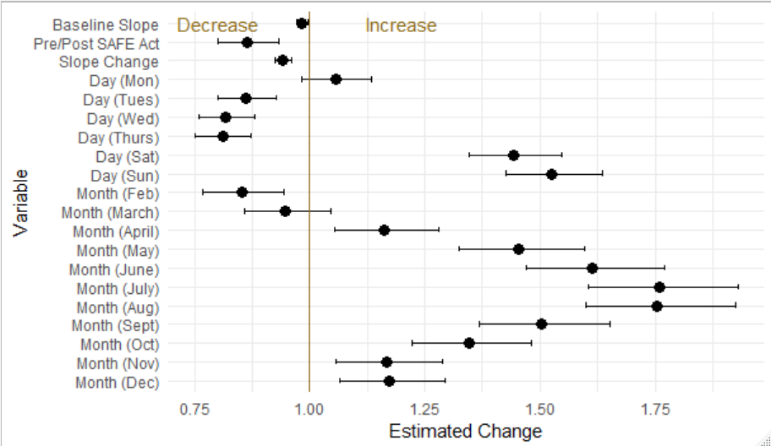

*Figure 2: Incidence Rate Ratios and Confidence Intervals for the negative binomial regression predicting number of reported shootings per day*

). The intercept represents a Friday in January, pre-intervention and was 3.88. On a typical Friday in January 2006, we anticipate 3.88 shootings may occur. The incident rate ratio for post-SAFE Act level shift was 0.86, indicating a 14% (95% CI 7%-20%) reduction in shooting incidence following act passage. February was the only month that had a significantly lower rate than January. We estimate that shooting incidence per day in the month of February is 15% (95% CI 6% - 23%) lower than that expected in January. All remaining months, excluding March, had significantly higher rate ratios than January. Highest rates were in July and August, about 75% higher than January. This agrees with the belief that shootings rise in warm weather and fall in cold weather.

The Baseline Slope variable seen above shows the general trend in shootings prior to the SAFE Act. Such indicates a 2% decline in shooting incidence per year. The Slope Change variable represents the change in slope seen following the passage of the SAFE Act. The slope steepened an additional 6% from the decline observed prior to legislative change.

# **Discussion**

When accounting for day of the week and month of the year, the estimated incidence of shooting on a given day after the SAFE Act was 14% lower than just before the SAFE Act. Shootings continued to decrease at a faster rate after the act’s passage, by an additional 6% per year. Looking at the shooting-free weekend (Friday, Saturday, Sunday) that occurred in October 2018, we estimated the expected number of shootings to be 10. For the same weekend in 2012, the year before implementation of the SAFE Act, we estimated 17 shootings would be reported. However, this is not a direct comparison due to 6 years of incidence reduction efforts outside of the SAFE Act. Had incidence decline followed its observed trend prior to the SAFE Act, the shooting-free weekend in October 2018 would have been expected to have 16 reported shootings.

# **Limitations**

The models assume that shootings on given days or months are independent of those that immediately precede them. This assumption is likely false but was made for ease of interpretation of the interrupted time series variables. Further work can be done to create a model that accounts for prior shooting incidence.

Additionally, these models did not include other gun violence interventions such as changes in policing practices and the Cure Violence program discussed in the introduction. Such changes were excluded due to the heterogeneous nature of such changes. No other intervention besides the SAFE Act impacted all of New York City at the same level or the same time. Including other interventions would have required greater granularity in model outcome. It is likely that these other interventions had a measurable impact on gun violence, but inclusion of such was beyond the scope of this study.

These findings reflect the temperature patterns observed in New York City and may not translate to areas with different seasonal patterns. And finally, the lack of 4th quarter 2019 data limits our ability to interpret 2019 patterns and decreases data available for these months.

# **Conclusion**

Following the SAFE Act, there was an immediate decrease in the incidence of gun violence in New York City by approximately 13%, and an accelerated incidence decline in following years by an additional 6% per year compared with the trend prior to the SAFE Act. Day of the week is a significant predictor of incidence rate with reported shootings rising on weekends and falling mid-week. Such makes the shooting-free weekend seen in October 2018 more surprising, though its likelihood has increased greatly in recent years. Month is also a significant predictor of shooting incidence with rates highest in June, July and August, and lowest in January and February. With an observed reduction in gun violence of 13% per day, our study supports the argument that comprehensive gun legislation such as the SAFE Act can have a significant immediate and longer-term impact on gun violence in states where such is passed.

References

1. JohnJayREC. (2019, July 10). The Effects of Cure Violence Programs in 2 New York City Neighborhoods. Retrieved from https://johnjayrec.nyc/2017/10/02/cvinsobronxeastny/
2. Larsen, D. A., Lane, S., Jennings-Bey, T., Haygood-El, A., Brundage, K., & Rubinstein, R. A. (2017). Spatio-temporal patterns of gun violence in Syracuse, New York 2009-2015. Plos One, 12(3). doi: 10.1371/journal.pone.0173001
3. Messner, D. J. L. (2008). Policing, drugs and the homicide decline in New York City in the 1990s. Policing: An International Journal of Police Strategies & Management, 31(1). doi: 10.1108/pijpsm.2008.18131aae.002
4. Paybarah, A. (2019, August 6). Gun Violence: New York's Own Problem. Retrieved from https://www.nytimes.com/2019/08/06/nyregion/newyorktoday/nyc-gun-violence.html
5. Seasonal Patterns in Criminal Victimization Trends. (n.d.). Retrieved from https://www.bjs.gov/content/pub/pdf/spcvt.pdf
6. States with Weak Gun Laws and Higher Gun Ownership Lead Nation in Gun Deaths, New Data for 2015 Confirms. (2017, January 10). Retrieved from https://vpc.org/press/states-with-weak-gun-laws-and-higher-gun-ownership-lead-nation-in-gun-deaths-new-data-for-2015-confirms/